How to put web app code on Azure Web app :

Refer : <https://docs.microsoft.com/en-us/azure/app-service/app-service-deploy-ftp>

1. Create an empty web on azure portal :

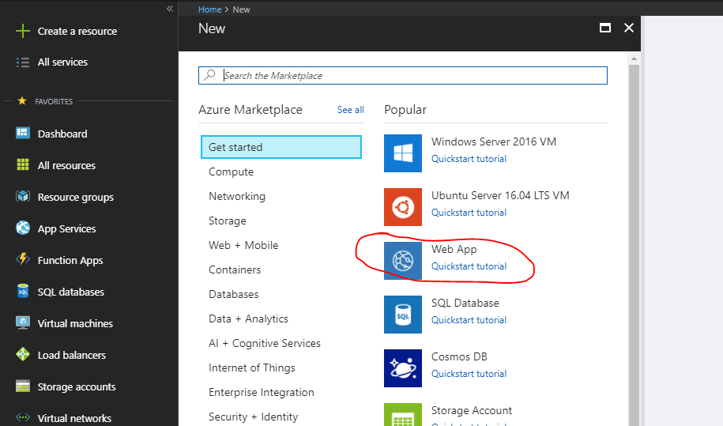

1. Create a Zip file for all your code files (353 files) lest say the zip file name is **mypublishedCode.zip**
2. We shall drag and drop this zip file to kudu.
3. Open the kudu console of web app from advance tool option , it will open a link for kudu of your web app

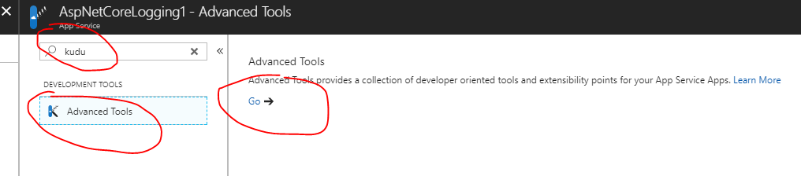

1. Go to debug console🡪 **CMD**

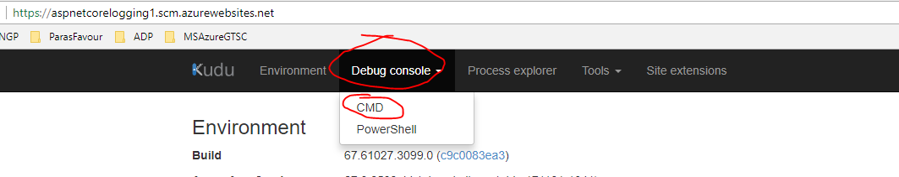

1. By default it has 3 folder , one of them is Site folder , we shall create files over there in **site🡪 wwwroot**

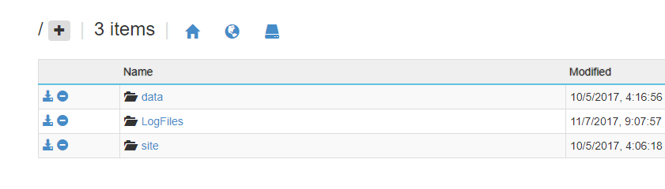

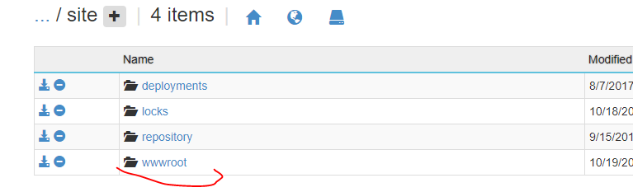

1. Now drag and drop that zip folder here :

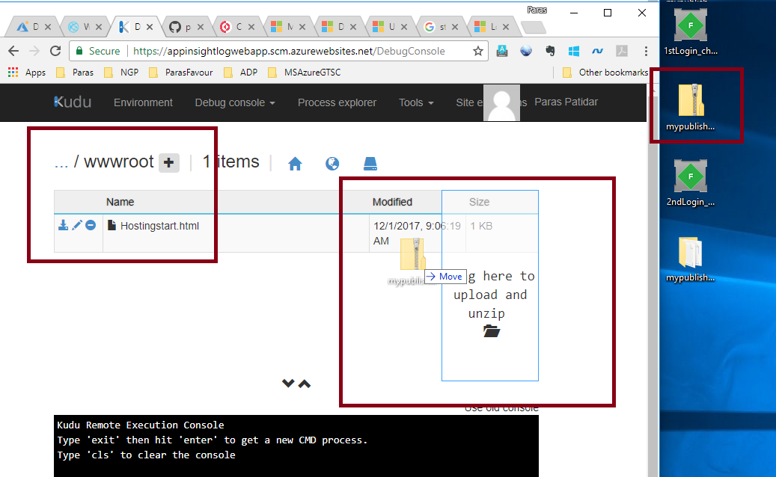

1. This will create the folder and unzip It as well (if this doesn’t unzip automatically then refer point 11):

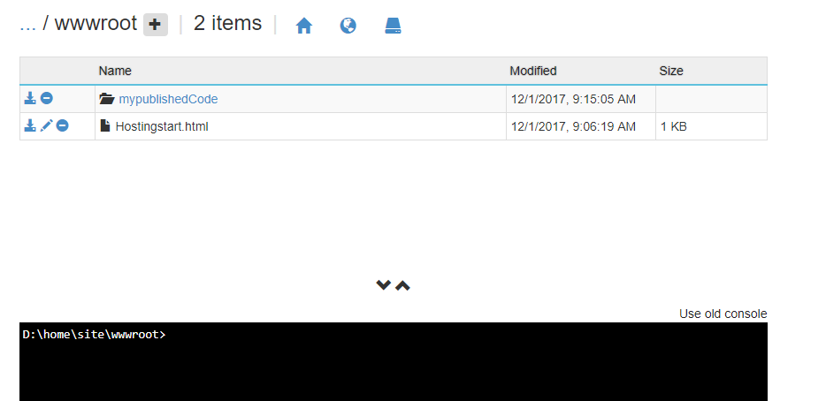

1. Now run the Xcopy command to copy all files here :

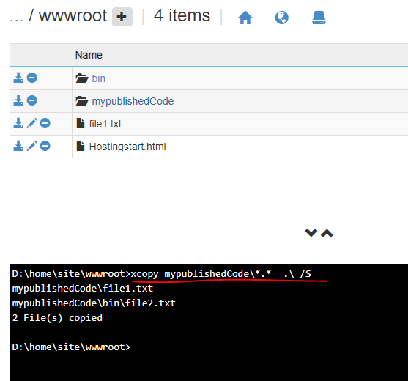

1. No delete the unused **mypublishcode** folder

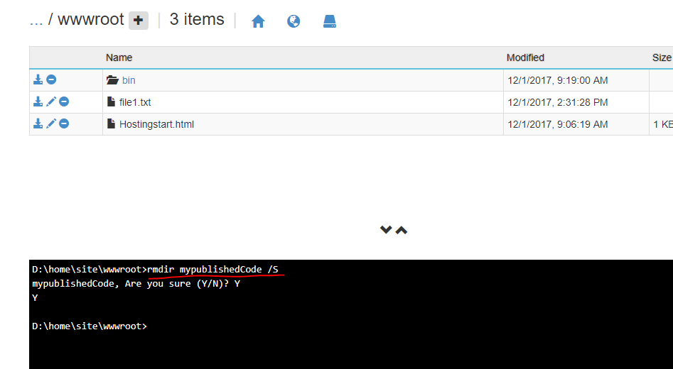

1. Please not in point number 7 , if we don’t copy the folder new Size column , where it says about drage here to copy and unzip , then it will not auto unzip.

To unzip any zip folder run this command :

